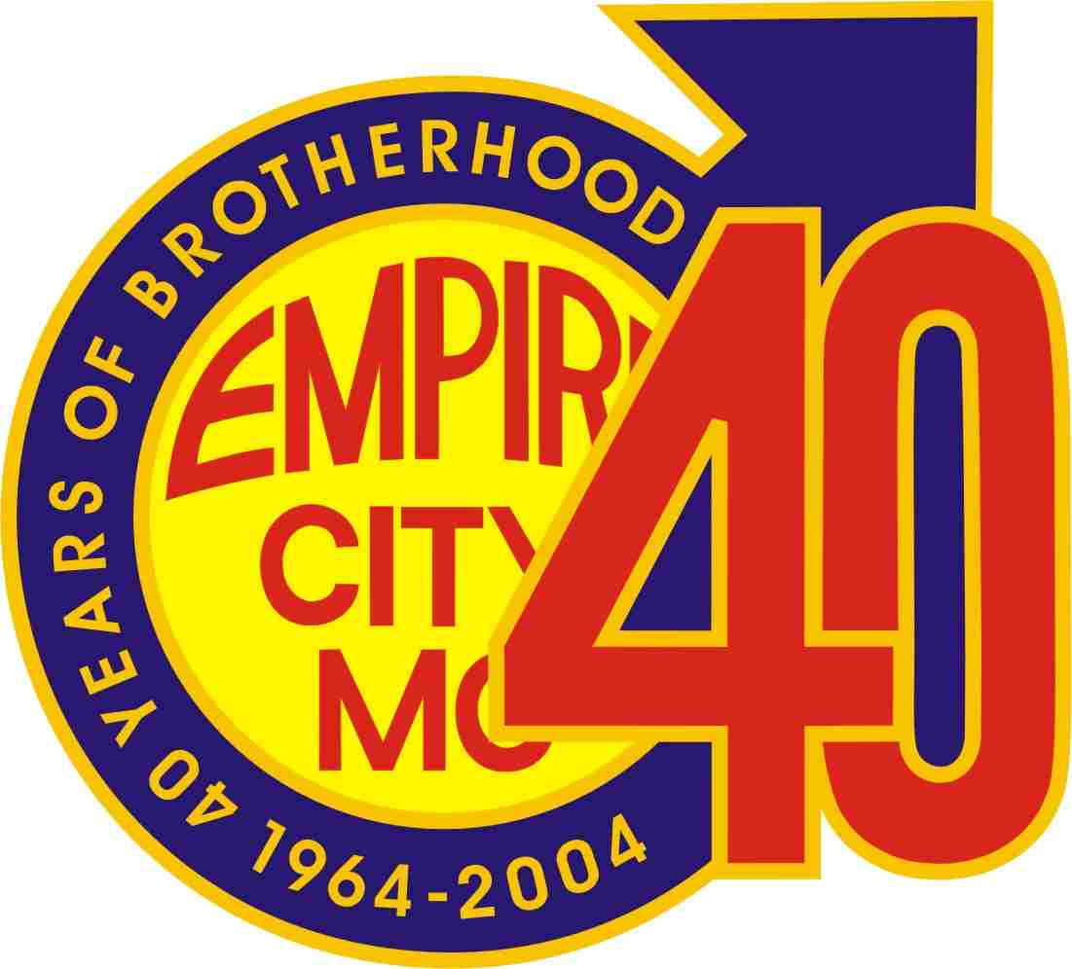
Empire City Motorcycle Club

Poker Run Saturday October 9, 2004

The following list of establishments will serve as Poker Card Dealers. The list provides the hours of operation and the special promotional offer. Show your run pin at each location to receive one poker card and to participate in their promotion offering. Please note: Only two locations will offer cards in sealed envelopes, they must be presented sealed Saturday aboard the Amberjack V, our yacht. All five cards should be taken with you on the cruise where you will play your hand. It is suggested that you begin at location 1, which will give you proper time to enjoy the game and promotions. You may visit any location in any order just make note of the hours of operation & what promotional offerings you will participate. Complete the game by 5:30 PM & have fun.

Location 1
museumofsex
Museum of Sex 233 Fifth Avenue (@ 27th Street) Hours of operation 11 AM to 8 PM (212) 689-6337 The museum will offer $5 off the general admission which is: Adults (18+): $14.50 + tax. Students and Seniors $13.50 + tax

Location 2
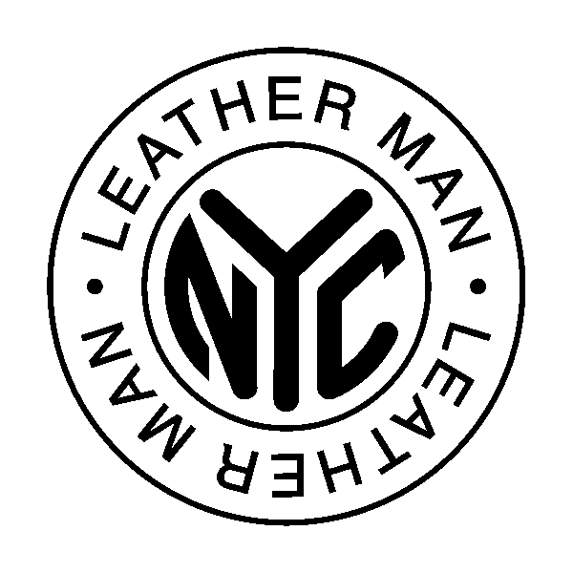
Leather Man NYC, 111 Christopher Street opens at 12 PM and is offering a 10% discount on items in the store! Please show your run pin to the staff to redeem your discount valid until Monday October 11, 2004.

Location 3
Manatus Restaurant, 340 Bleecker Street between Christopher and 10th Street. Show your run pin and they will offer a 10% discount all Saturday & Sunday. Stop by for a relaxing Brunch, Lunch or Dinner.

Location 4
Ty's Bar, 114 Christopher Street. Door opens at 3pm Sat, offering a second drink free. Go to the bar and pick up your card and don’t forget your drink ticket (valid all weekend) in the run package.

Location 5
The Dugout located at 185 Christopher near the West Side Highway. Sat 3 PM their door will open early for participants on the poker run. They too will be offering a second drink free, just present your ticket (valid all weekend).

