Welcome To All

Gathering of Toys
Cocktails and Hors d' Oeuvres
6:00 - 7:30 PM

Welcome
7:30 PM

Terry Puffer, President, ECMC

Buffet Dinner
7:45 - 8:45 PM
Melanzane - Rigatoni alla Siciliana
Pollo Parmigiana della Mamma
Scaloppine Saltimbocca – Salmone
Gonna Bistecca con Salsa Verde

A Few Words
8:45 PM

Mark Wind & Debra McCall

Door Prizes Galore!
9:00 PM

Have your tickets ready for a fabulous prize!

Dessert
Coffee, Teas & Assorted Pastries

VISIT OUR WEBSITE
WWW.EMPIRECITYMC.COM

Empire City Motorcycle Club
2008 Officers

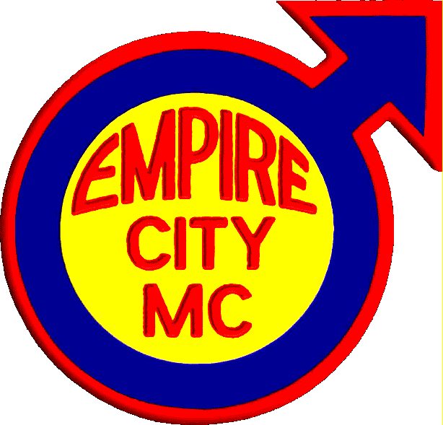

Terry Puffer President / Secretary

Skip Dailey Vice President

Ed Murphy Road Captain

Mark Wind Treasurer

Empire City Motorcycle Club Inc. of New York City was founded by a group of twelve motorcycle riders in October 1964 as a motorcycle owner/rider club. We are the oldest ongoing gay all riding organization in the country and a vital part of the gay community in New York metropolitan area. Our members are male owners/operators of motorcycles. At its first public Christmas Party in 1964, the club began collecting toys for tots. This focus was narrowed in 1987 to respond to the needs of children with AIDS, and now includes other medically challenged children.

Our Event Benefits Leake and Watts Services. Leake and Watts provides Specialized Foster Care in temporary homes for children who are HIV-positive and/or have AIDS, as well as those who are medically fragile (e.g. Spina Bifida, Down Syndrome, heart and liver disorders). These children are provided additional medical case management and support services (such as visiting nurse services), and the foster parents receive training on specific illnesses/disorders. The Early Permanency Planning Project, which also services HIV-affected children, provides support services to terminally ill parents who wish to plan for their children's future.

