47th Annual Holiday Party

and Toy Drive

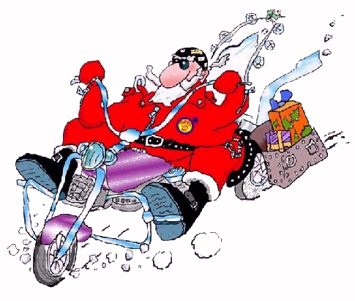

Saturday, 4th December 2010

Pangea Restaurant
178 2nd Ave, NYC

