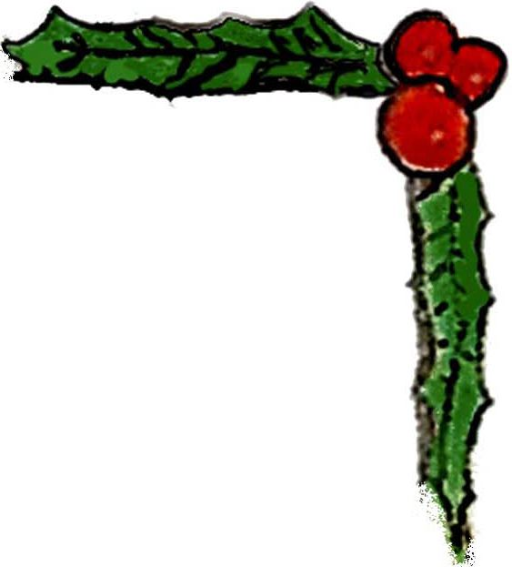
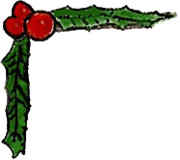

Welcome To All

Gathering of Toys
Cocktails and Hors d' Oeuvres
6:00 - 7:30 PM

Welcome
7:30 PM - Eddie Murphy, President, ECMC

Dinner is Served
7:45 - 8:45 PM

A Few Words
8:45 PM - Mark Wind & Debra McCall

Door Prizes Galore!
9:00 PM - Fabulous prizes!

Dessert
Coffee, Teas & Assorted Pastries

Join us for a ‘Pub Crawl’ ending at Ty’s
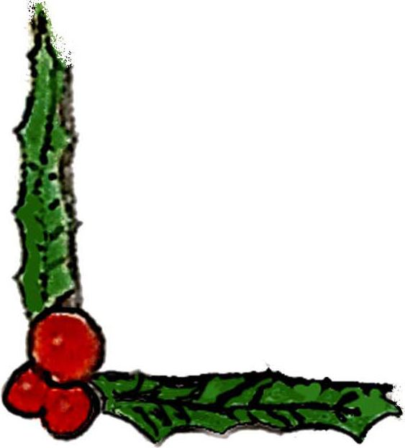
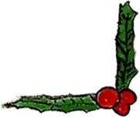
10:00 PM – Travel with us bar-to-bar, on foot!

Did you know we’re on the web?
Check out our new website!
www.EmpireCityMC.com

