Empire City Motorcycle Club
2010 Officers & Event Statement
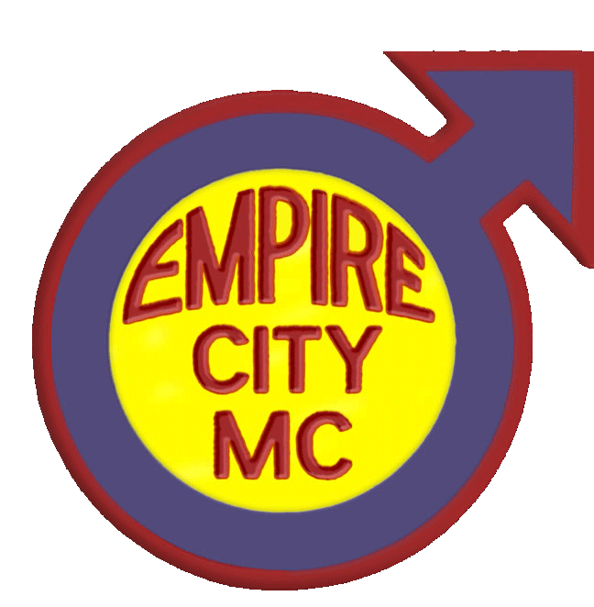
Eddie Murphy,
President

Chaz Antonelli,
Vice President

Skip Daily,
Road Captain

Terry Puffer,
Secretary

Mark Wind,
Treasurer

Empire City Motorcycle Club was founded in October of 1964 and is a Not-for-Profit Corporation in the State of New York. It is the oldest contiguous gay organization east of the Rockies. Our members are male owners/operators of motorcycles. At our first public Christmas Party in 1966, the club began collecting toys. In 1987, this focus was narrowed to respond to the needs of children with AIDS. It now includes other medically challenged children.

Our Event Beneficiary is “Leake and Watts Services” who provides Specialized Foster Care in temporary homes for children who are HIV-positive and/or have AIDS, as well as those who are medically fragile (e.g. Spina Bifida, Down Syndrome, heart and liver disorders). These children are provided additional medical case management and support services (such as visiting nurse services) and the foster parents receive training on specific illnesses/disorders. The Early Permanency Planning Project, which also services HIV-affected children, provides support services to terminally ill parents who wish to plan for their children's future.

If you are interested in information or providing additional assistance for Leake and Watts Services, please contact Debra McCall at Leake and Watts Services, 463 Hawthorne Ave, Yonkers, NY 10705. Or phone at 718-829-8174.

The members and officers of Empire City Motorcycle Club thank you for helping us support this worthy cause. A special thank you goes to members of brother-clubs and dear friends whom have travelled great distances each year to support this event! We couldn’t do it without you!

Remember to mark your calendars and attend our Annual Biker Weekend (Bike Blessing & Biker’s Picnic), this coming year, it will be the 3rd–6th June 2011. Visit www.EmpireCityMC.com for details.

