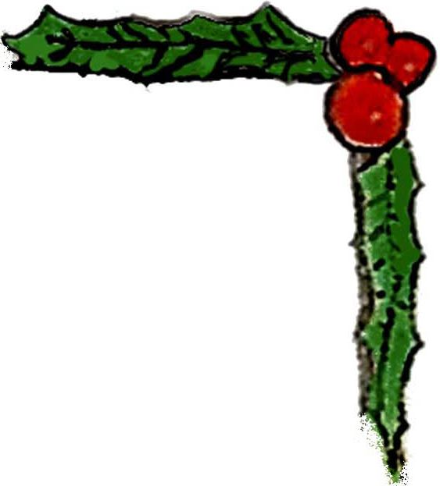
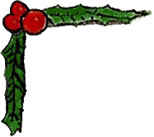


Fabulous Door Prizes!

- Men and Machine Harley Davidson Calendar 2011
- Dinner for two at Pangea ($75 Value)
- $50 Visa Gift Card
- $50 Visa Gift Card
- $50 Visa Gift Card
- $50 Visa Gift Card
- Moet & Chandon Champagne
- Moet & Chandon Champagne
- Dinner for two at Cafe' Loup ($100 Value)
- $40 Starbucks Gift Card
- Dinner for 2 at Gascogne ($100 Value)
- A 50cl bottle of Sebor Absinth from the Czech Republic
- $25 Starbucks reloadable card & a coffee mug and one pound of Starbucks Christmas blend coffee
- $25 Starbucks reloadable card & a coffee mug and one pound of Starbucks Christmas blend coffee
- Studded Leather Wristband from Steve Leathers
- Rock Edition of Absolute Vodka
- $20.00 Drink Certificate Courtesy The Hangar
- Two $25.00 Drink Certificates Courtesy of Ty's
- Fifteen (15) Free Drink Coupons Courtesy of Boots and Saddles
- $50.00 Gift Card Courtesy of The New York City Leatherman
- $125.00 (Plus $20.00 Shipping) Voucher Courtesy of Botanica Florist owned and operator by partners Bob and Les

