Celebrating our 48th Annual Holiday Party and Toy Drive

in loving memory of our fallen brother, Jeff Arnold.

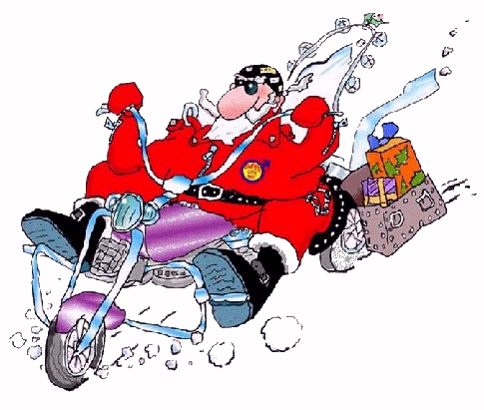

Saturday, 3rd December 2011

Pangea Restaurant
178 2nd Ave, NYC

