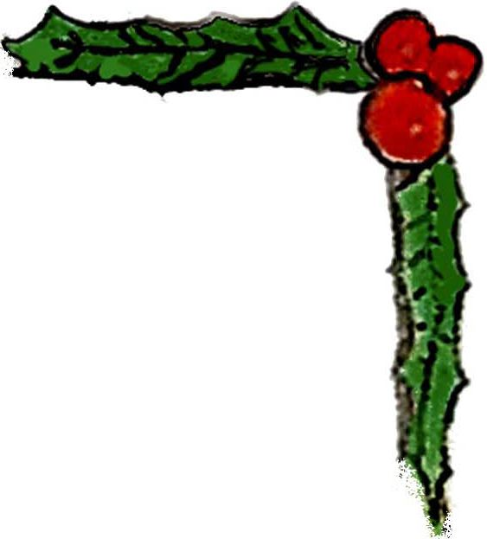
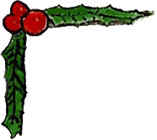

Welcome To All

Gathering of Toys
Apéritifs/Cocktails and Hors d'Oeuvres
6:00 - 7:30 PM

Welcome
7:30 PM – Chaz Antonelli, Vice President, ECMC

Dinner
7:45 - 8:45 PM

A Few Words With…
8:45 PM - Mark Wind & Debra McCall

Door Prizes
9:00 PM - Fabulous prizes!

Dessert
Coffee, Teas & Assorted Pastries

Digestifs/Cocktails
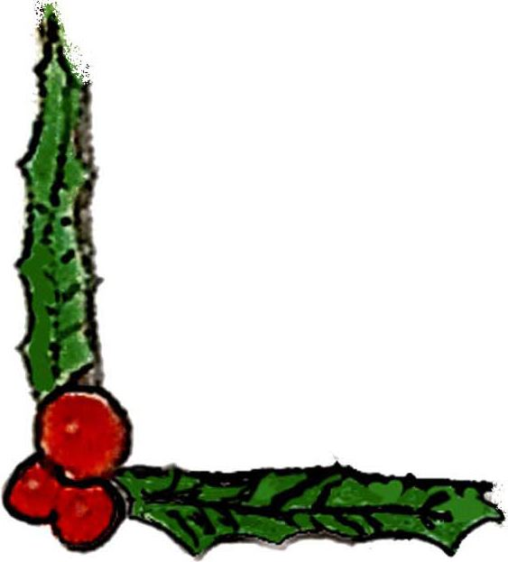
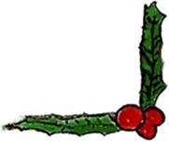
10:00 PM – Join us bar-to-bar: Stonewall, Ty’s & Rockbar

Did you know we’re on the web?
Check out our new website!
www.EmpireCityMC.com

