
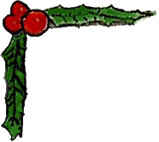

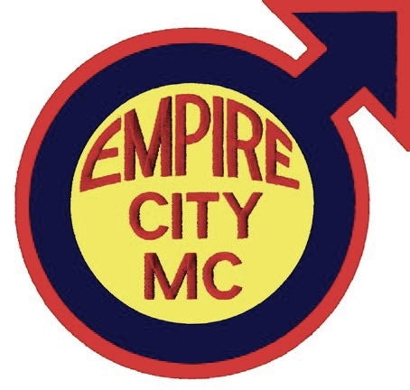
Fabulous Door Prizes!

- 2012 Men and Machines Harley Davidson Calendar
- Dinner for two at Pangea
- $50 Leatherman Gift Card
- Starbucks mug, 1 lb of coffee, 1 $15 gift card (thanks to Paul Rose)
- Starbucks mug, 1 lb of coffee, 1 $15 gift card (thanks to Paul Rose)
- Massage therapy at "The Beach" on Christopher St
- Studded leather encased Absolute, Rock Edition
- MUMM Champagne
- MUMM Champagne (Thanks to Terry P)
- 25,000 Delta Air Miles (domestic round-trip flight) (Thanks to K.K. Kua)
- $50 MasterCard Gift Card (Thanks to Terry P.)
- $50 MasterCard Gift Card (Thanks to Terry P.)
- "Come to our event free" -- a $55 debit card
- Dinner for Two at Cafe Loup ($75 value, gratuity not included)
- $100 gift card for Universal Gear on 8th Ave
- $125 Kiehl's Gift Box
- $125 Kiehl's Gift Box
- $125 Kiehl's Gift Box
- $125 Kiehl's Gift Box
- $150 dinner for two at Blue Water Grill
