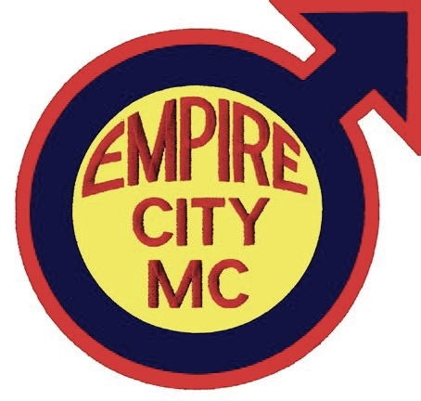
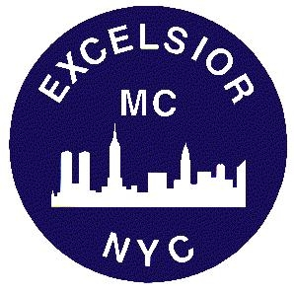
Join Empire City, M.C.
and Excelsior, M.C.
for our first joint barnight
at the D.C. Eagle

Saturday, 14th January 2012
starting at 9PM
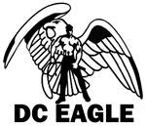

639 New York Ave NW,
Washington, D.C.



