Empire City Motorcycle Club
2011 Officers & Event Statement
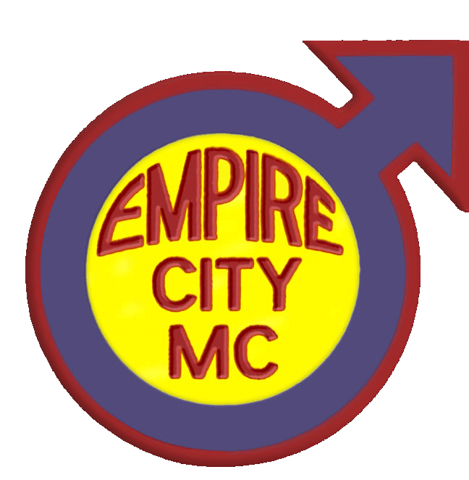
Eddie Murphy,
President

Chaz Antonelli,
Vice President

Barry Kloda,
Road Captain

Alexander Hadel,
Secretary

Mark Wind,
Treasurer

Empire City Motorcycle Club was founded in October of 1964 and is a Not-for-Profit Corporation in the State of New York. It is the oldest running organization east of the Rockies for gay men. We are motorcycle owners and operators. At our first public Christmas Party in 1966, the club began collecting toys. In 1987, this focus was narrowed to respond to the needs of children with AIDS. Today, it includes other medically challenged children.

Our beneficiary is “Leake and Watts Services.” They provides Specialized Foster Care in temporary homes for children who are HIV-positive and/or have AIDS, as well as those who are medically fragile (e.g. Spina Bifida, Down’s Syndrome, coronary and hepatic disorders). These children are provided additional medical case management and support services (such as visiting nurse services). Their foster parents also receive training on treating specific illnesses/disorders. Please visit www.leakeandwatts.org for more information.

If you are interested in providing additional assistance for Leake and Watts Services, please contact Debra McCall at Leake and Watts Services, 463 Hawthorne Ave, Yonkers, NY 10705. 718.794.8274 (office) and dmccall@leakeandwatts.org (e-mail).

The members and officers of Empire City Motorcycle Club thank you for helping us support this worthy cause. A special thank you goes to members of brother-clubs and dear friends who have travelled great distances each year to support this event! We couldn’t do it without you!

Upcoming ECMC events include:

A joint barnight with Excelsior, M.C. at the D.C. Eagle in Washington, D.C. 14th January 2012 and our free Annual Biker Weekend (Bike Blessing & Biker’s Picnic) in the Spring of 2012.

Please visit www.EmpireCityMC.com for additional details.

