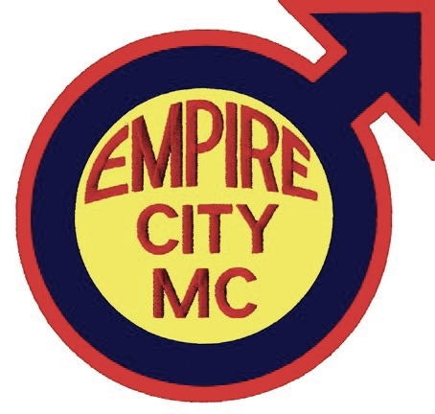
Empire City M/C’s Annual Biker Weekend – June 1-3, 2012
Information and Run Application

With the help of many friends of the club and the dedication of ECMC members, we’re very excited to announce the return of a whole weekend riding experience with meals, overnight accommodations and more! Join ECMC for all or part of the weekend

Friday, June 1st: Motorcycle Christening/Blessing at Ty’s (NYC)

Saturday, June 2nd: Ride with us along the Delaware River to a Biker Lunch
Stay with us at “The Ranch” in Hemlock NY

Sunday, June 3rd: Ride with us along the Finger Lakes and through PA

In order to best prepare and accommodate everyone, we ask that you carefully review the ride as outlined and submit your completed application to ECMC promptly.

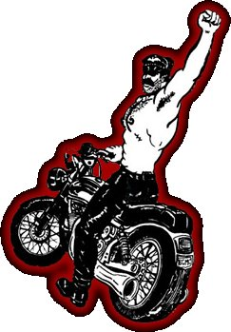
This is a motorcycle only event! No four-wheeled vehicles are allowed! Empire City M/C understands there are riders from all over the northeast that would like to participate in this event without having to enter New York City. There are several meet-up points and times specified in the maps below. Please follow the directions provided so we know where to expect you. As always, this run is a FREE event (with the exception of Saturday morning’s breakfast, Sunday afternoon’s lunch and any of your personal expenditures.)

Name _____________________________________________________________

Club Affiliation (if any) ________________________________________________

Address ______________________________________________________________

City __________________________ State ________ Zip ___________________

Phone Number (_________)____________-_______________________________

Don’t forget the legal crap…

I, ____________________________, certify that I have attained at least twenty-one (21) years of age and that I, based upon mutual covenants & considerations, will not hold the Empire City Motorcycle Club, Inc. (a.k.a. ECMC) nor the individual and collective officers, members, servants, agents, employees thereof liable for any injury to my person or property during the period of the Empire City M/C Annual Biker Weekend 2012. I further agree to indemnify, save harmless and hold harmless the Empire City Motorcycle Club, Inc. (a.k.a. ECMC) or the individual and collective officers, members, servants, agents, employees thereof from any and all liability, serious injury, economic loss, and any other loss arising from whatever event, source, manner and/or nature which they may suffer as a result of claims, demands, costs or judgments against them, individually and/or collectively, arising out of their individually and/or collectively granting to me the privilege of attending & participating in part and/or whole of the Empire City M/C Annual Biker Weekend 2012.

Signature ____________________________________________________________ Date __________________

Once you’ve completed the filling in the planning portion (with the maps below), you must mail this application to our Road Captain for processing. Remember: Bed space will be assigned on a ‘first registered, first served’ basis, so don’t delay!

Please read the directions carefully and return all three pages by U.S. Mail to:

Empire City M/C Annual Biker Weekend
c/o Road Captain
PO Box 1881
New York, NY 10011-1881

If you have any questions, please call Chaz Antonelli at +1 646 827-6222 (7pm-10pm EDT M-F)
Please tick the boxes “” below in which you will be meeting up with us and will be riding with us. For example, if you will meet up with us at the Citgo, have lunch in Hancock, then leave – tick “Stop B and Stop C”, but not A or D.

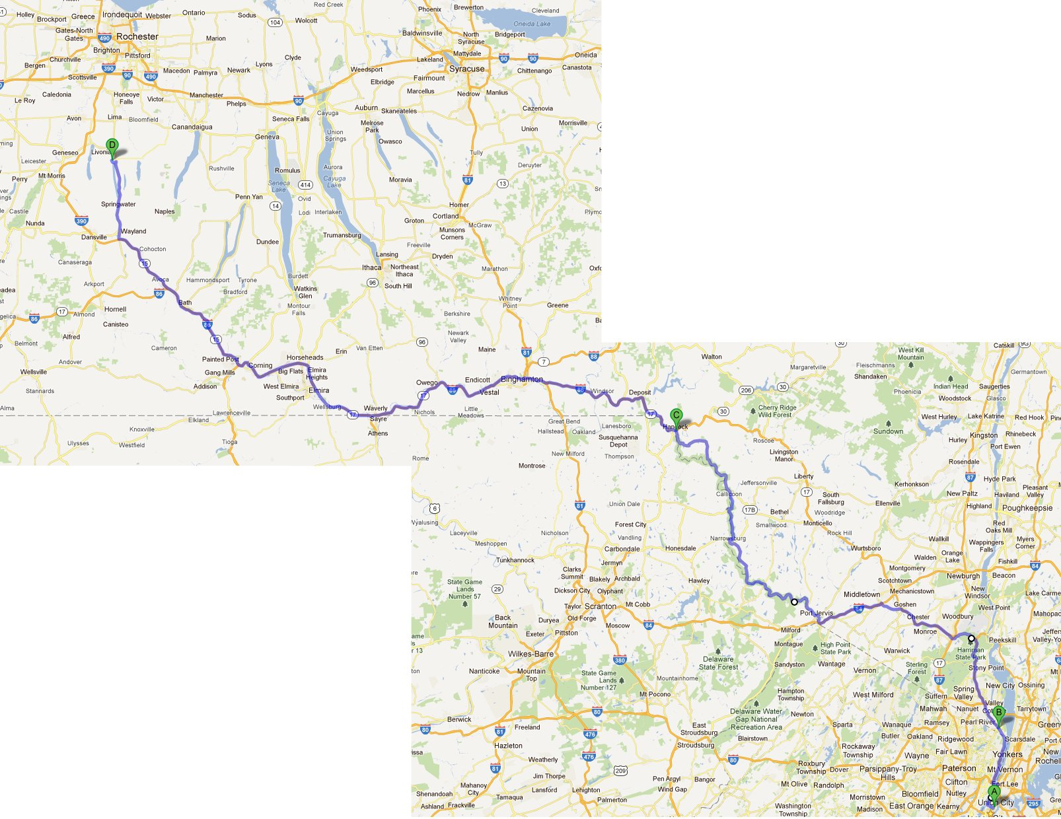

 Stop A, 8AM/9AM – Breakfast
Lexington Candy Shop, 1226 Lexington Ave, New York, NY 10028

If you want to eat breakfast, please arrive no later than 8AM. We shall depart at 9AM sharp! The Lexington Candy Shop is a classic 50’s malt shoppe with a hearty breakfast and smooth coffee! Note: Breakfast here is “dutch treat”.

 Stop B, 10AM – Meet up
CItgo gas station on the Palisades Parkway just beyond mile marker 12
when heading north. Be ready with full
tanks and empty bladders! Meet in the
large parking lot on the north side of the
rest area. We will leave at 10AM sharp
from this stop. We will ride up the picturesque Palisades Parkway to US-6
and then onto a fantastic road for riding
road that follows the river, featuring
some nice twisties up NY-97, ending in Hancock, NY.

 Stop C, 1PM/2:30PM – Lunch! Empire City M/C treats you to a prix fixe menu at “Honest Eddy Murphy’s Tap Room” in the Hancock House Hotel (137 E Front St, Hancock, NY 13783). We will arrive around 1PM, eat, stretch and then we will gas up and depart no later than 2:30PM. There is ample parking in back of this wonderful restaurant and bar where we can relax and grab a bite.

 Stop D, 6:00PM – ECMC will treat you to a steak/chicken BBQ dinner at “The Ranch” in Hemlock, NY. The Ranch is the home of Al Rizzo and Dan Marty, who are close friends of the club and have donated their space for us to host our Saturday night dinner and arrival party. In addition to bed space for the night, this large farmhouse and finished barn in the rolling countryside of the finger lakes region features a swimming pool, hot tub, billiards table, fully-stocked bar and a large “playroom” for those that enjoy reclining in a “leather hammock” for a spell. (wink, wink!) Don’t over-pack - linens and towels are provided. Bed space will be assigned on a ‘first register, first served’ basis. There are some sleeping bags for any overflow and space in the TV lounge for sleeping. Some of the Rochester Rams M/C will come down and party with us!

See the exact map of the outbound ride at http://j.mp/ECMC2012a


Important: Did you remember tick the box for each event/ride
you’re planning to attend in the list above?
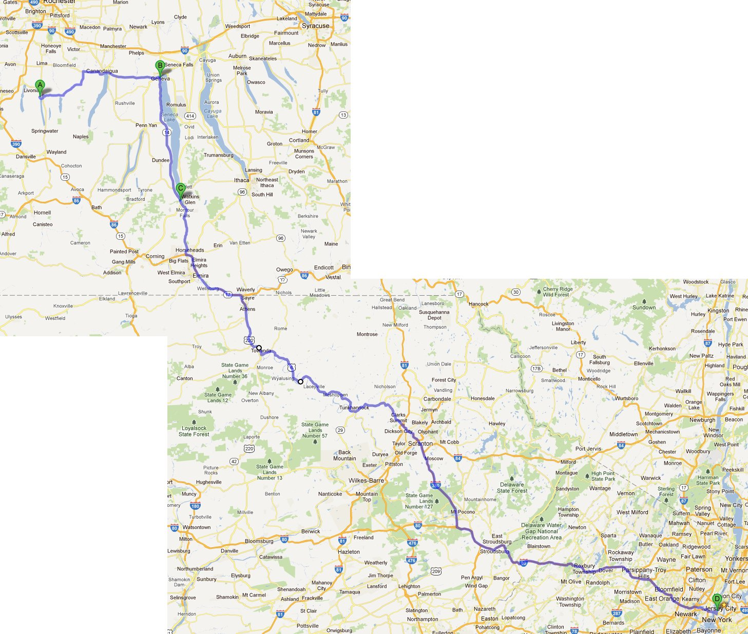

Here is our planned ride, returning to Ty’s in New York City on Sunday, June 3rd. We understand that not everyone will want to come all the way back to the city and may want to split off from the group.

Please tick the boxes “” below to indicate at which stops you will still be with us. Please an “X” on the route of where you intend to leave the group, if that is your intention.

 Starting point A, 12 o’clock Noon – Be prepared to leave promptly at noon. We shall ride through some rolling countryside, passing a few towns, villages and some finger lakes themselves, including Honeoye Lake, Canandaigua Lake and riding alongside the entire length of Seneca Lake. We shall make gas stops and breaks as deemed necessary by the group. When we come into Geneva, NY there are several traffic lights and we may be split up.

 Stop B, 1PM – We have established a re-group point (if needed) on Route 14 South, just as you leave the 5 & 20. The exit for Route 14 is clearly marked and is just before the bridge that goes over the 5 & 20. Our re-group shall be on the right side of the road once on Route 14 South.

 Stop C, 2PM – Photo Op at Watkin’s Glen State Park in the car park by the waterfall! Gas up at the Valero and grab a snack/lunch at the Burger King or the Great Escape Ice Cream Shop. We will depart at 2:30PM sharp. Note: We will make fuel/food stops as requested by the group from this point forward, we expect a number of New Jersey/Pennsylvania riders to leave our group between Stop C and D.

 Stop D, roughly 7:30PM – We arrive at Ty’s Bar in New York City for a celebratory beer or two!

See the exact map of the inbound ride on the web at http://j.mp/ECMC2012b

Important: Did you remember tick the box for each event/ride
you’re planning to attend in the list above?

