

Empire City MC is proud to announce their
50th Annual Holiday Party & Toy Drive
an AMCC sanctioned event
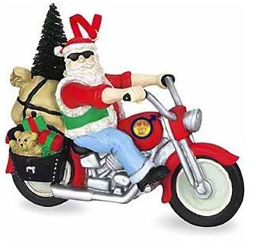
Saturday, December 7th
6:30pm-9:30pm at Rockbar
185 Christopher St, New York City
We're celebrating our 50th Annual Holiday Party and Toy Drive by lowering the cost of the event and going back to our roots, making this more of a social party than a sit-down dinner.
Tickets $25 in advance (online) or $30 at the door
    - Free soft drinks all night, compliments of Rockbar NYC.
    - Complimentary "rockshot" or beer for all guests!
    - Fantastic door prizes. Coat check.
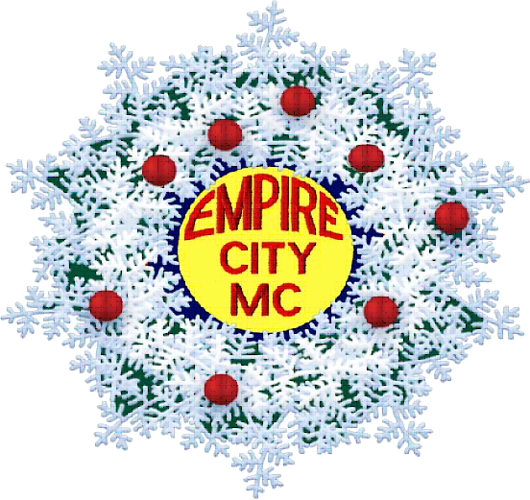
    - Plenty of light fare and appetizers all night!
Remember to bring a new, unwrapped
gift or toy suitable for a child or teenager
to benefit Leake & Watts Services!
Tickets are on sale NOW at:
http://ecmc-50th-xmas.eventbrite.com
or go to www.EmpireCityMC.com



For more information or to donate a door prize, please contact Evil Ed my e-mail at: vice-president@empirecitymc.com

