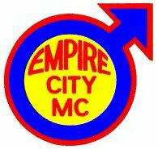

Dear Sir / Madam:

Empire City Motorcycle Club of New York was founded by a group of twelve motorcycle riders in October 1964 as a motorcycle owner/rider club. We are one of the oldest ongoing gay all riding organization in the country and a vital part of the gay community in the New York metropolitan area.

For the past 50 years Empire City Motorcycle Club has hosted an annual Holiday Party & Toy Drive. Since the early 1980’s, we have worked closely with “Leake and Watts Services, Inc.” who are located at 1529-1535 Williamsbridge Road in the Bronx. Leake and Watts Services provides temporary homes for children, and adults, who are medically fragile (e.g. spinal bifida, Down syndrome, heart and liver disorders). These children / adults are provided additional medical case management and support services such as visiting nurse services, and the foster parents receive training on specific illnesses/disorders.

As part of our 50th Annual Holiday Party & Toy Drive on Saturday, December 7th, 2013, members of the Empire City Motorcycle Club are soliciting door prizes for our event. The door prizes for this benefit help promote your company/organization and will be listed on the advertisement with your specific contact information.

We would appreciate anything suitable for a door prize for our annual benefit event. While a large majority of our guest are gay men, our event does draw in a variety of attendees (men & women) who’s ages vary from 21 to 70 years old. Most are from the New York City metropolitan area.

Along with your door prize contribution, please consider passing this information about our event on to your staff and/or advertising our event on your website. All adults (21+) are welcome to purchase a ticket and attend this worthy event. If you or your staff is interested, tickets are available at http://ecmc-50th-xmas.eventbrite.com/ or by completing the form attached.

I thank you for your time and consideration. Please feel free to contact me at (XXX-XXX-XXXX) or by e-mail at (enter your email address) in respect to this event.
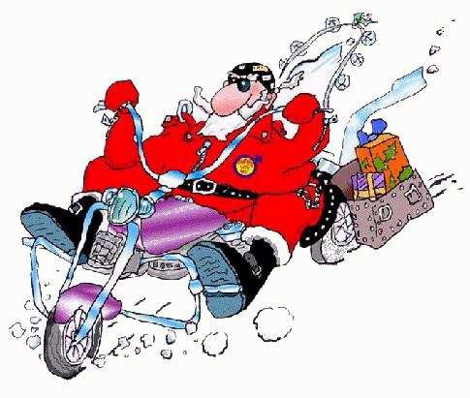

Sincerely,

(Type in your name)

(Type in your name),
Empire City MC,
Toy Drive Committee

