


Empire City MC is proud to announce our
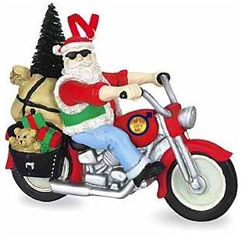
51st Annual Holiday Party & Toy Drive
Saturday, December 6th
6 PM - 9 PM at Stonewall Inn
53 Christopher St, New York City
Our 51st Annual Holiday Party and Toy Drive for Leake & Watts will be simple and fun again this year in a private social setting with light fare.

Tickets $25 in advance
or $30 at the door

    - Fantastic door prizes. Coat check.
    - Plenty of light fare/appetizers all night!
    - Holiday Jell-O Shots and more surprises!

    - Make it a weekend! Excelsior MC’s Trim-a-Tree on Dec 5th

Don’t forget to bring a new, unwrapped
gift or toy suitable for a child or teenager
to benefit Leake & Watts Services!
Tickets are on sale online now at
www.EmpireCityMC.com or
complete the reverse and mail it in

For more information about our event or to


donate a door prize, please contact our Vice President,
Eddie, by e-mail at: vice-president@empirecitymc.com

Mail-in Ticket Order Form

Please complete and mail this form to:

Empire City MC Holiday Party
PO Box 1881
New York, NY 10113-1881

Name ____________________________________
Club (if any) _______________________________
e-Mail ____________________________________
Phone ____________________________________
Address __________________________________
City ________________ State ____ Zip _________

Quantity of tickets ____ at $25/ea, total _$______

All tickets will be held in buyer’s name at the door,
identification may be required. Confirmation will be
done by electronic mail, or in the event there is no
e-mail address provided, by telephone.

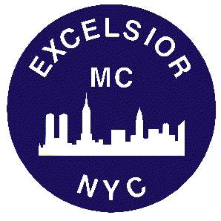
Visit www.ExcelsiorMC.com for information about Excelsior MC’s Trim-a-Tree on December 5th

