ECMC’s 2014 Holiday Party – Door Prizes!
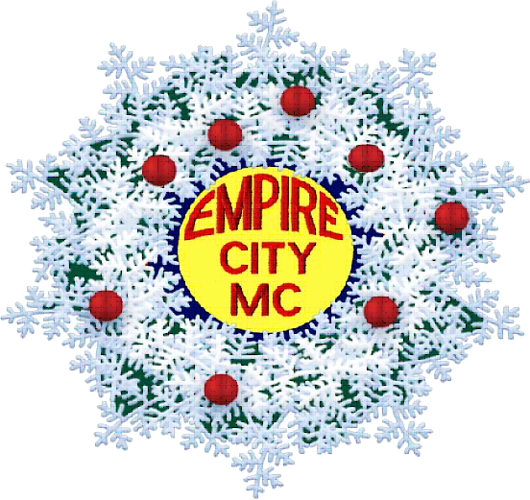

- 2015 Men and Machines Calendar
- $75 Gift Certificate for Cafe Loup
- Banned in many countries, a bottle of Absinthe from the far east!
- Motorcycle-themed Hallmark Christmas ornament
- Basket of wine and assorted Trader Joe Sundries
- Basket of wine and assorted Trader Joe Sundries
- Basket of wine and assorted Trader Joe Sundries
- $150 Gift Certificate from Palm Restaurant in Philly
- $50 Gift Certificate for ‘Tavern’ on Camac in Philly
- $40 Gift Certificate for Cocktails from U-Bar in Philly
- $50 Visa Gift Card (Terry P)
- $50 Visa Gift Card (Terry P)
- Replica 1948 Ford F-1 Pick-up (Paul R)
- Replica 1928 JDH Twin Cam (Paul R)
- $50 Gift Certificate for The Leatherman
- 42” Leather Vest (The Leatherman) & pair of
34x36 Leather Pants (Rubio Leathers)
- Nioxin system kit (Hair by Giorgio)
- Nioxin system kit (Hair by Giorgio)
- Styling Gel by American Crew (Hair by Giorgio)
- Styling Gel by American Crew (Hair by Giorgio)
- Body Lotion Kit by Hempz (Hair by Giorgio)
- Weekend Registration for Excelsior MC & Twilight
Guard’s Anniversary Run on Fire Island (Excelsior)

