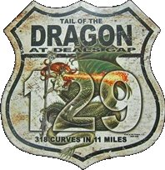
Empire City MC’s 50th Anniversary
week-long motorcycle tour to the
Tail of the Dragon, Deals Gap, NC

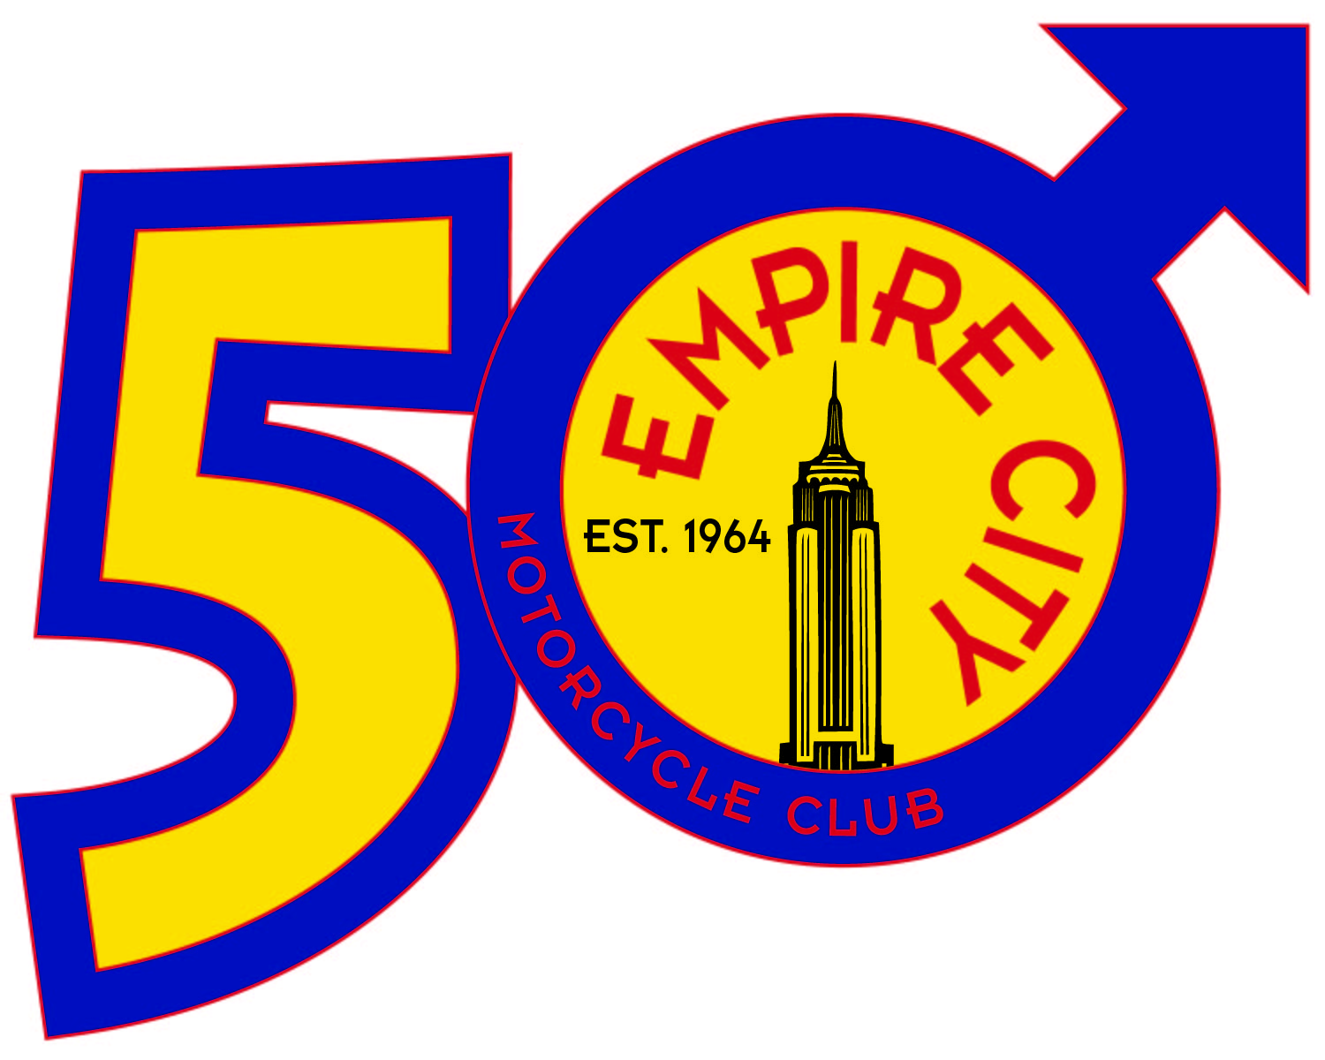
AUGUST 2nd-10th 2014
OFFICIAL RUN APPLICATION
LIMITED SPACE – DON’T DELAY!

Your $250 run fee includes:

- A guided, formation ride from New York City
- One afternoon picnic and one evening formal dinner
- Accommodations at Iron Horse Motorcycle Lodge
- 24x7 beer & soft drinks at our private lodge
- Six home-made breakfasts at our private lodge
- ECMC limited edition commemorative 50th Anniversary run pin

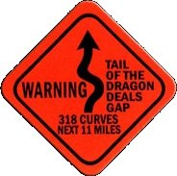
What’s not included:

- Hotel accommodations at our ½ way points
(estimated at $50/pp double occupancy each way)
- Dinners, lunches, snacks and other meals not
included in what’s mentioned above

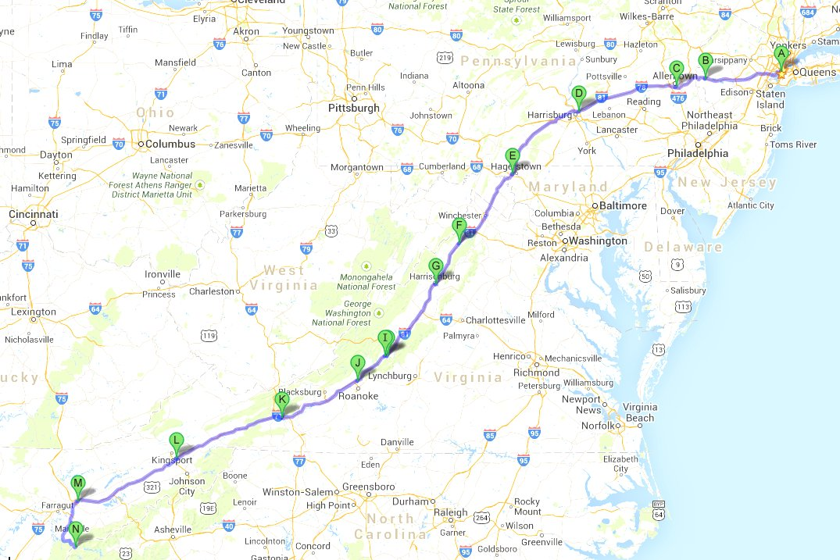

This is a motorcycle only event! No four-wheeled vehicles are allowed! We understand there are riders from all over that would like to participate in this event without having to enter New York City; therefore we have several meet-up points and times. For detailed information, including meet-up points, online payment and other information, please visit our special website at http://EmpireCityMC.com/totd

Each participant must complete a run application (the reverse of this form) and mail it in, or if paying online, present this completed form when meeting up with us. We will contact you by e-mail for any additional information.

PLEASE COMPLETE THE FORM BELOW AND MAIL IT IN.

By participating in our event, you agree to ride safely as per the directions of our Road Captain,
understanding he has final say. Furthermore, you certify your motorcycle is in safe working order
and you have the proper riding experience to safely complete this journey.

Your information

Name ____________________________________________________________

Club Affiliation (if any) ________________________________________________

E-Mail Address _____________________________________________________

Address ___________________________________________________________

City __________________________ State _________ Zip __________________

Phone Number (______) _______ - ____________ I am: □ Buddy Rider / □ Rider

Emergency Contact Name _____________________________________________

Emergency Contact Phone Number (______) _______ - ____________

Accommodations preferences

I prefer to be in the □ Quiet Cabin or □ Standard Cabin

Each of the five rooms in our two cabins will accommodate two people. You have a choice of a king size bed in your room (sleeps two persons), or two double beds. If you are choosing the king size bed option, you must specify who is bunking with you and they must also specify you as their bunkmate. We will try to accommodate everyone with their selection; however, if there is an issue, we will contact you by e-mail or telephone to make arrangements. Room configurations must be submitted no later than 30 days prior to our event, otherwise double beds are standard.

I prefer □ two double beds or □ one king size bed (read note above before ticking!)

I prefer to bunk with ______________________________ (If you do not choose a roommate, one will be assigned)

I have the following dietary restrictions ____________________________________

Please read and complete the waiver

I, _____y o u r n a m e___________, certify that I have attained at least twenty-one (21) years of age and that I, based upon mutual covenants and considerations, will not hold Empire City Motorcycle Club, Inc. (a.k.a. ECMC) nor the individual and collective officers, members, servants, agents, employees thereof liable for any injury to my person or property during the period of Empire City MC’s 50th Anniversary Deals Gap Ride. I further agree to indemnify, save harmless and hold harmless Empire City Motorcycle Club, Inc. (a.k.a. ECMC) or the individual and collective officers, members, servants, agents, employees thereof from any and all liability, serious injury, economic loss, and any other loss arising from whatever event, source, manner and/or nature which they may suffer as a result of claims, demands, costs or judgments against them, individually and/or collectively, arising out of their individually and/or collectively granting to me the privilege of attending and participating in part and/or whole of Empire City MC’s 50th Anniversary Deals Gap Ride.

Signature ____________________________________________________________ Date __________________

This event has extremely limited space – don’t delay! Please read the directions carefully and return this page with your payment of $250 (or pay online) by mail to:

Empire City MC Deals Gap Ride
PO Box 1881
New York, NY 10011-1881

Additional details and online payment available at http://EmpireCityMC.com/totd

