Empire City MC’s 50th Anniversary Weekend
October 10-11-12, 2014 • New York City

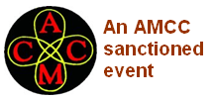
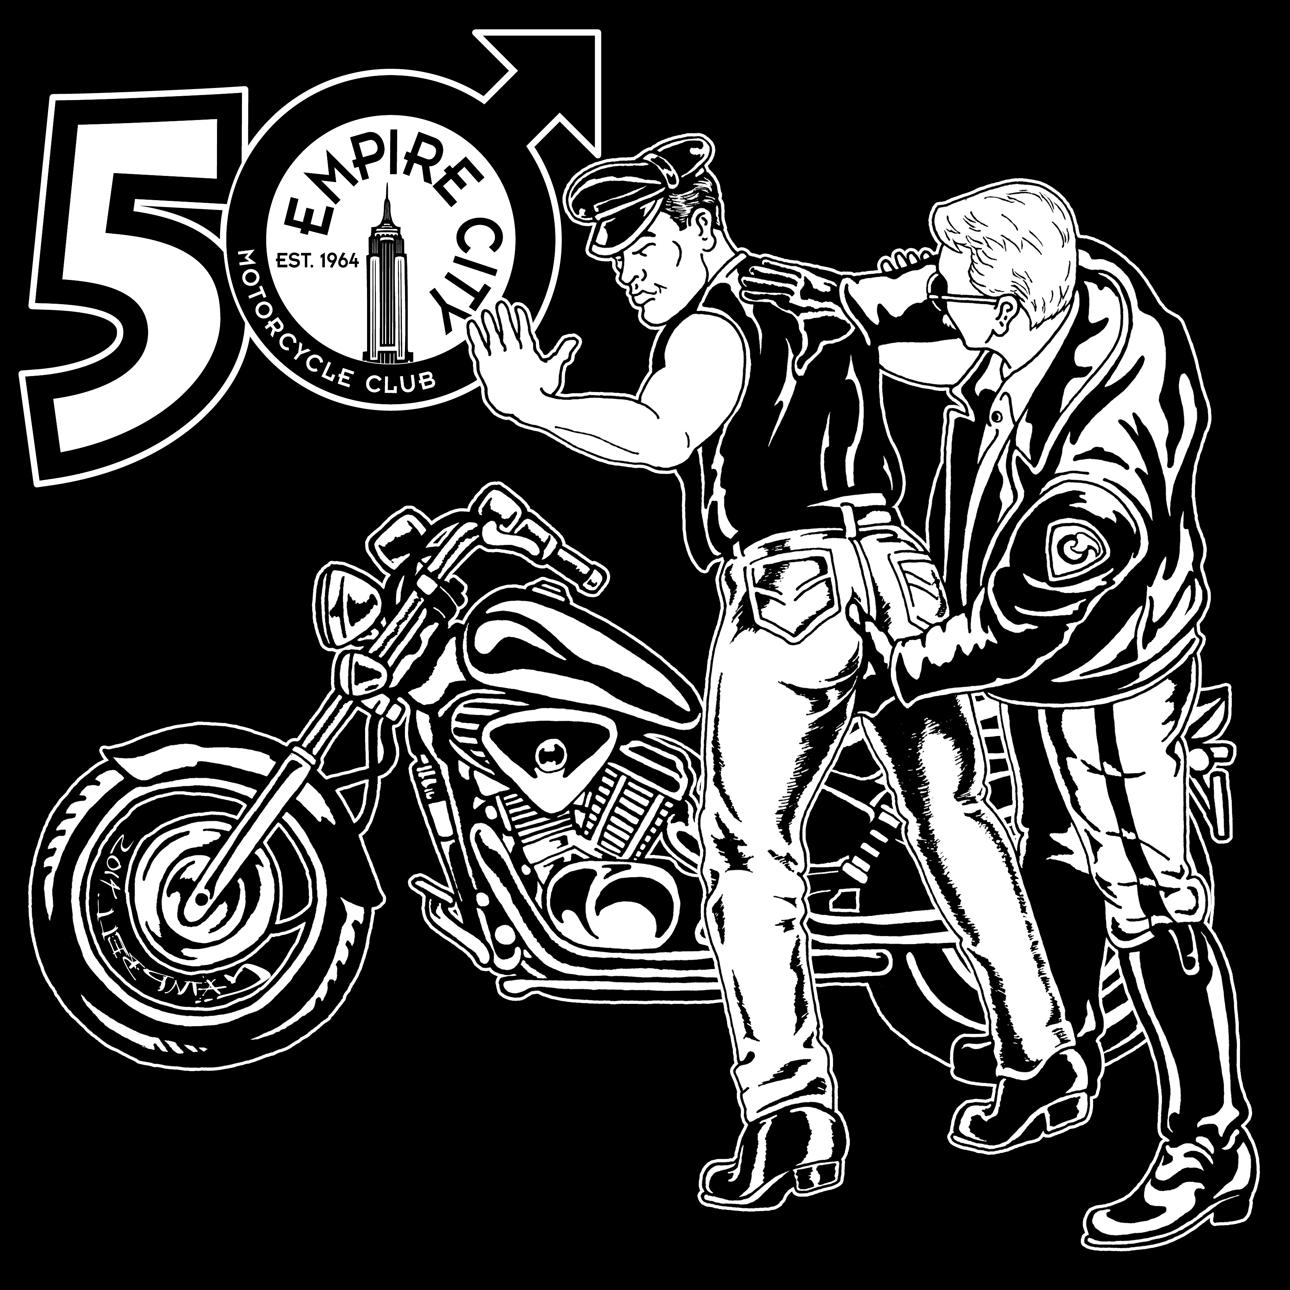

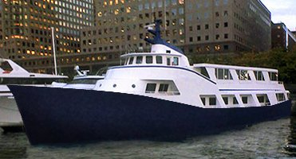
Full-Weekend Package Includes:

✵ Formal dinner and dance cruise on
our private yacht with open bar
✵ Hospitality suite at host hotel
✵ Saturday afternoon motorcycle tour
✵ Meals, snacks, soda/beer
✵ Cocktail parties
✵ Barnight at Rockbar NYC
✵ Invasion of NYC Eagle

Max capacity 100, register now! Run application on reverse.

Each participant must complete a run application (below) and mail it in, or if paying online, present this completed form when checking in at registration. We will contact you by e-mail for any additional information. For detailed information, online payment and other information, please visit http://EmpireCityMC.com/
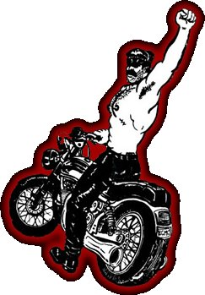
PLEASE COMPLETE THE FORM BELOW AND MAIL IT IN.

Your Information

Name ____________________________________________________________

Club Affiliation (if any) ________________________________________________

E-Mail Address _____________________________________________________

Address ___________________________________________________________

City __________________________ State _________ Zip __________________

Phone Number (______) _______ - ____________

Emergency Contact Name _____________________________________________

Emergency Contact Phone Number (______) _______ - ____________

Package Options (please tick one)

❑ $189.00 – Early-bird full weekend package (before August 15th, 2014)
❑ $199.00 – Standard full weekend package (after August 15th, 2014)
❑ $129.00 – Early-bird dinner/dance yacht cruise with open bar only (before August 15th, 2014)
❑ $139.00 – Standard dinner/dance yacht cruise with open bar only (after August 15th, 2014)

Accommodations

Our host hotel is the DoubleTree in Jersery City, NJ which is a short walk to the PATH train which brings you into the city with a convenient stop at Christopher Street in the West Village.

Accommodations at our host hotel are separate from the run fee – you must make hotel reservations yourself. We have negotiated a limited number of discount suites at the hotel at a rate of $145/night (1-2 people) and $165/night (3-4 people). Discount hotel parking for motorcycles and automobiles for our guests is $15/day.

Make your reservations today at: http://j.mp/hotel-res or by calling 1-800-222-TREE and using booking code “ECM”.

Please read and complete the waiver

I, _____y o u r n a m e___________, certify that I have attained at least twenty-one (21) years of age and that I, based upon mutual covenants and considerations, will not hold Empire City Motorcycle Club, Inc. (a.k.a. ECMC) nor the individual and collective officers, members, servants, agents, employees thereof liable for any injury to my person or property during the period of Empire City MC’s 50th Anniversary Weekend. I further agree to indemnify, save harmless and hold harmless Empire City Motorcycle Club, Inc. (a.k.a. ECMC) or the individual and collective officers, members, servants, agents, employees thereof from any and all liability, serious injury, economic loss, and any other loss arising from whatever event, source, manner and/or nature which they may suffer as a result of claims, demands, costs or judgments against them, individually and/or collectively, arising out of their individually and/or collectively granting to me the privilege of attending and participating in part and/or whole of Empire City MC’s 50th Anniversary Weekend.

Signature ____________________________________________________________ Date __________________

Please read the directions carefully and return this page with payment by post to:

Empire City MC Anniversary Weekend
PO Box 1881
New York, NY 10113-1881

Additional details and online payment available at http://EmpireCityMC.com/

