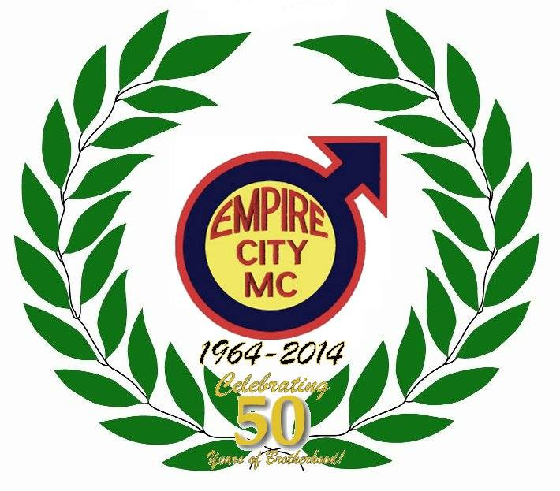
October 10 -12, 2014

Jersey City, NJ

