Empire City Motorcycle Club
Presents
Born To Run
50 Glorious Years
01. U2 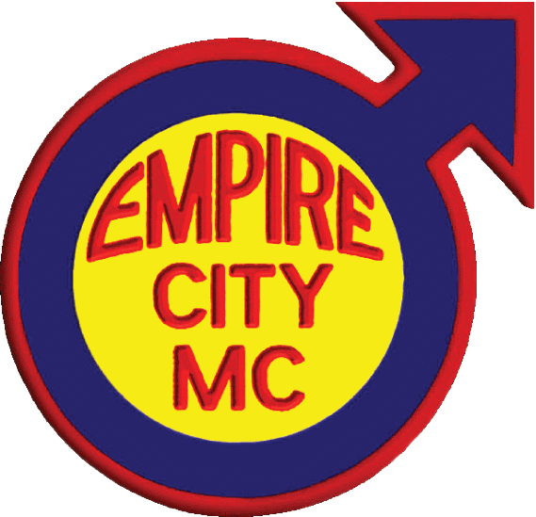 Where the Streets Have No Name
02. Led Zeppelin Good Times Bad Times
03. Creedence Clearwater Revival Ramble Tamble
04. The Doors The Changeling
05. Bob Seger & The Silver Bullet Band Against The Wind
06. The Beatles In My Life
07. Sniff `N' The Tears Driver's Seat
08. Stereo MC's Connected
09. LL Cool J Mama Said Knock You Out
10. Thin Lizzie The Boys Are Back In Town
11. Bachman Turner Overdrive Roll On Down The Highway
12. Steppenwolf Born to Be Wild
13. ZZ Top Rough Boy
14. Sailcat Motorcycle Mama
15. The Jimi Hendrix Experience Purple Haze
16. Bruce Springsteen Born To Run
17. The Allman Brothers Band Jessica
18. Willie Nelson On The Road Again
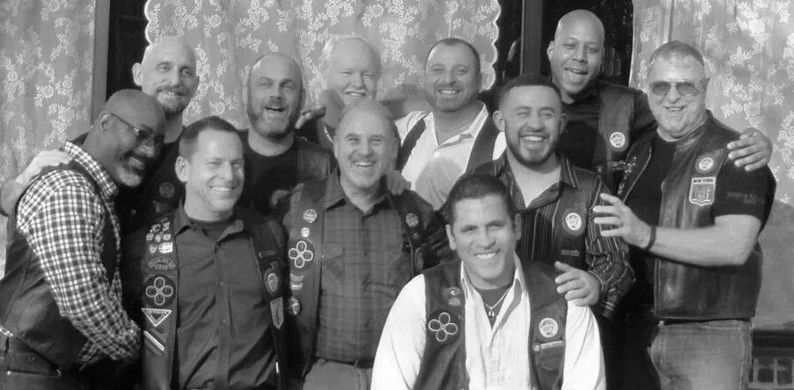
Compilation 2014: Gabriel Rivas/Excelsior MC
Cover Art: Chaz A.
All other art: K.K. Kua

