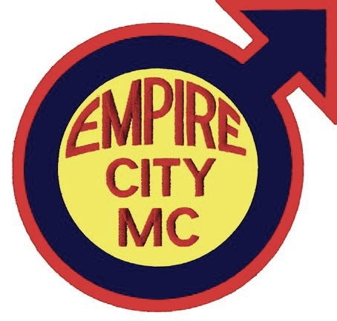
Empire City MC’s Annual Biker Weekend – May 22nd – 25th, 2015
Information and Run Application

With the help of many friends of the club and the dedication of ECMC members, we’re very excited to announce another great Memorial Day weekend riding experience with some meals, accommodations and more! Won’t you join ECMC for all or part of the weekend?

Friday, 22nd May ……… Ride with us to “The Ranch” in Hemlock, NY through
scenic New Jersey, Pennsylvania and the Southern Tier
of New York State with multiple breaks/pick-up points.

Saturday, 23rd May ….. Explore upstate New York’s Finger Lakes region!
Sunday, 24th May ……. Explore upstate New York’s Finger Lakes region!

Monday, 25th May …… Ride with us back to New York City.

In order to best prepare and accommodate everyone, we ask that you carefully review the ride as outlined and submit your completed application with $35/per person run fee to Empire City MC before May 15th.

This is a motorcycle only event! No four-wheeled vehicles are allowed! We understand there are riders from all over that would like to participate in this event without having to enter New York City; therefore we have several meet-up points and times specified in the map on page two. Accommodations at The Ranch, two dinners and two breakfasts are included in your run fee of $35 per person. Each person must complete this form and send it in.
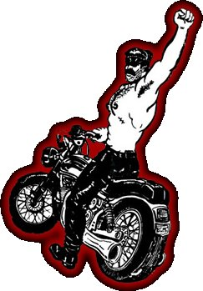
Name ____________________________________________________________

Club Affiliation (if any) ________________________________________________

E-Mail ____________________________________________________________

Address ___________________________________________________________

City __________________________ State _________ Zip __________________

Phone Number (______) _______ - ____________ I am: □ Buddy Rider / □ Rider

I will meet up the group at (see map on page 2): □ A, □ B, □ C, □ D, □ E, □ F

Emergency Contact Name _____________________________________________

Emergency Contact Phone Number (______) _______ - ____________

I, ____________________________, certify that I have attained at least twenty-one (21) years of age and that I, based upon mutual covenants and considerations, will not hold Empire City Motorcycle Club, Inc. (a.k.a. ECMC), Al Rizzo/Dan Marty (a.k.a. The Ranch) nor the individual and collective officers, members, servants, agents, employees thereof liable for any injury to my person or property during the period of Empire City MC’s Annual Biker Weekend 2015. I further agree to indemnify, save harmless and hold harmless Empire City Motorcycle Club, Inc. (a.k.a. ECMC), Al Rizzo/Dan Marty (a.k.a. The Ranch) or the individual and collective officers, members, servants, agents, employees thereof from any and all liability, serious injury, economic loss, and any other loss arising from whatever event, source, manner and/or nature which they may suffer as a result of claims, demands, costs or judgments against them, individually and/or collectively, arising out of their individually and/or collectively granting to me the privilege of attending and participating in part and/or whole of Empire City MC’s Annual Biker Weekend 2015.

Signature ______________________________________________________________________ Date _______________

Once you’ve completed the filling in the planning portion (with the maps below), you must mail this application to our Road Captain for processing. Remember: Bed space will be assigned on a ‘first registered, first served’ basis, so don’t delay!

Please read the directions carefully and return this page with payment ($35 per person) by U.S. Mail to:

Empire City MC Annual Biker Weekend
PO Box 1881
New York, NY 10113-1881

Save time: Apply online at http://ecmc-2015-bw.eventbrite.com

Don’t forget to tick the box on page one to let us know where you’re meeting up with us! Furthermore, it’s vital that your motorcycle is in good working order and you are on time to your respective meet-up location.

Meet-up Point “A” (Lexington Candy Shop, New York, NY)
09:00 - 10:00 ... Breakfast at Lexington Candy Shop, 1226 Lexington Ave at 83rd St, New York, NY 10028
10:00 - 10:45 ... Kickstands up from Lexington Candy Shop and ride 33.9 mi (~0:42)

Meet-up Point “B” (Wendy’s in Parsippany, NJ)
10:45 - 11:15 ... Gas up at Sunoco, bathroom/snack break and meet-up at Wendy's, 736 U.S. 46, Parsippany-Troy Hills, NJ 07054
11:15 - 12:45 ... Kickstands up from Wendy's and ride 101 mi (~1:36)

Meet-up Point “C” (Pilot Truck Stop in Drums, PA)
12:45 - 13:15 ... Gas up, bathroom/snack break at Pilot Travel Centre, SR 93 I-80/81/PA 93 Exit 256, Drums, PA 18222
13:15 - 14:30 ... Kickstands up from Pilot Travel Centre and ride 85.3 mi (~1:19)

Meet-up Point “D” (Truck Stop in Trout Run, PA)
14:30 - 14:45 ... Gas up, bathroom/snack break at Steam Valley Restaurant/Truck Stop, 169 Pennsylvania 14, Trout Run, PA 17771
14:45 - 16:15 ... Kickstands up from Steam Valley Truck Stop and ride 103 mi (~1:36)

Meet-up Point “E” (Mobil in Wayland, NY)
16:15 - 16:30 ... Gas up, bathroom/snack break at Mobil Mini Mart, 26 E Naples St, Wayland, NY 14572
16:30 - 17:00 ... Kickstands up from Mobil Mini Mart and ride 16.4 mi (~0:22)

Meet-up Point “F” (The Ranch in Hemlock, NY)
17:00 ............... Arrive at The Ranch, 4872 Blank Rd, Hemlock, NY 14466

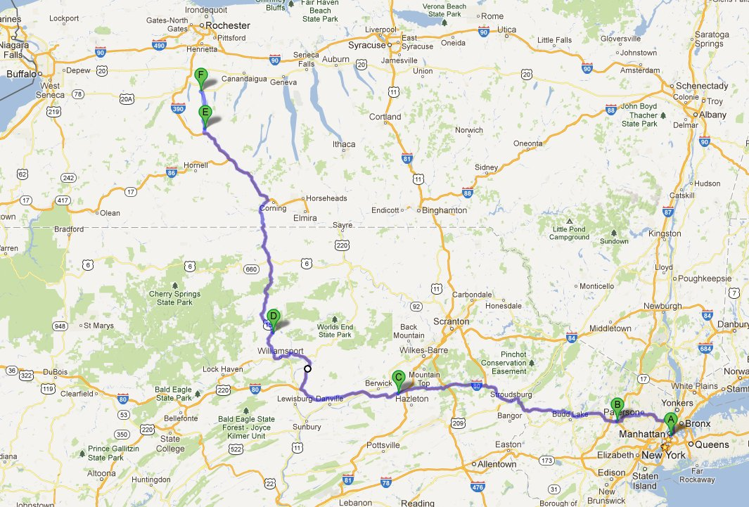

Bed, clean linens and towels will be provided by ‘The Ranch’, but for your safety and comfort, we recommend you bring the following:

■ tool kit  extra bungee cords  rain gear (hope we don’t need it!)
■ bike cover  driving license  motorcycle registration
■ mobile phone charger  personal medications  motorcycle insurance card
■ dry clothing  your club colours (vest)  favourite sex toy (optional) ;-)

The Ranch has play space (should you be interested), as well as a pool, hot tub, full bar, nature trails and more! Read more about what the Ranch has to offer at http://www.empirecitymc.com/files/the-ranch.htm

Save time: Apply online at http://ecmc-2015-bw.eventbrite.com

