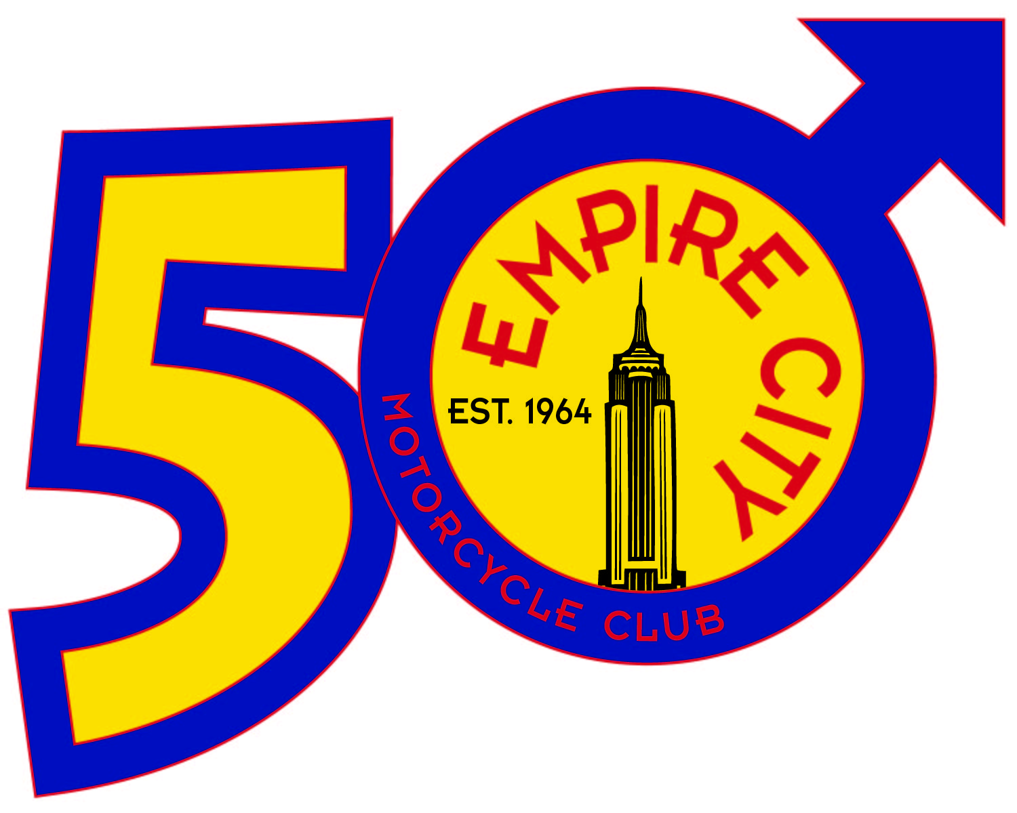
Empire City MC.
Biker Weekend..
Schedule of Events.

Monday
6pm-8pm - Dinner
8pm-late - Chill at the bar

Saturday
9am-11am - Brunch
11am-5pm - Motorcycle Ride #1* (lunch on road)
6pm-8pm - Dinner
8pm-late - Chill at the bar

Sunday
9am-11am - Brunch
11am-5pm - Motorcycle Ride #2* (lunch on road)
6pm-8pm - Dinner
8pm-late - Chill at the bar

Monday
9am-11am - Brunch
11am – Return home…

* Rides to be determined by group. Options include:

- Niagara Falls – U.S. side (3.5 hours riding)
- Finger Lakes – various options and length
- City of Rochester & Charlotte – (2 hours riding time)
- Sodus Bay – a local Motorcycle Hangout (3 hours riding)
- Seabreeze Amusement Park – (1.5 hours riding time)
- Darian Lake Amusement Park – (2 hours riding)
- Lucy/Desi Museum, Jamestown, NY – (4.5 hours riding)
- Other suggestions?

