Empire City MC’s Annual Motorcycle Weekend - May 25th – 28th, 2018
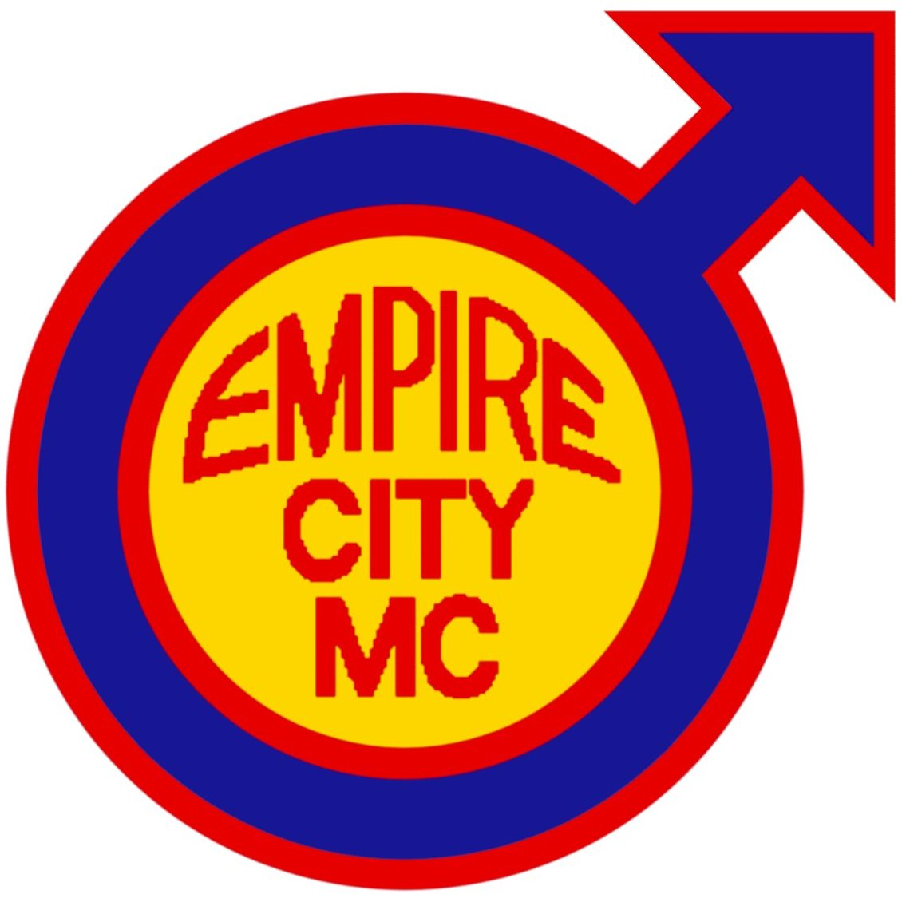
Information and Run Application

With the help of many friends and the dedication of ECMC members, we’re excited to announce another great Memorial Day Weekend riding experience including some meals, accommodations and more! Won’t you join ECMC for Motorcycle Weekend?

Friday, 25th May ……… Ride with us to “The Ranch” in Hemlock, NY through the scenic
Hudson Valley Region and the Southern Tier of New York State
with multiple breaks/pick-up points.

Saturday, 26th May …. Explore upstate New York’s Finger Lakes region!

Sunday, 27th May ……. Explore upstate New York’s Finger Lakes region!

Monday, 28th May …… Ride with us back to New York City.

In order to best prepare and accommodate everyone, we ask that you carefully review the ride as outlined and submit your completed application with $40/per person run fee to Empire City MC before 16th May, 2018. Space is limited to 20 bikers/buddies!

This is a motorcycle only event! No four-wheeled vehicles are allowed! We understand there are riders from all over that would like to participate in this event without having to enter New York City; therefore, we have several meet-up points and times specified in the map on page two. Included for your $40 run fee are: Accommodations at The Ranch, three dinners and three breakfasts, open bar all weekend at The Ranch. Each person must complete this form and send it in.
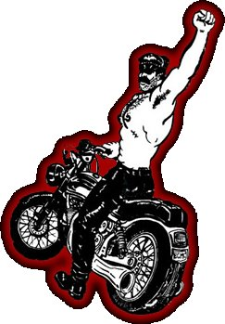
Name ____________________________________________________________

Club Affiliation (if any) ________________________________________________

E-Mail _____________________________________________________________

Address ____________________________________________________________

City __________________________ State _________ Zip ___________________

Phone Number (______) _______ - ____________ I am: □ Buddy Rider / □ Rider

I will meet up at (see map on page 2): □ A, □ B, □ C, □ D, □ E, □ F, or □ G

Emergency Contact Person _____________________________________________

Emergency Contact Phone Number (______) _______ - ____________

I, ____________________________, certify that I have attained at least twenty-one (21) years of age and that I, based upon mutual covenants and considerations, will not hold Empire City Motorcycle Club, Inc. (a.k.a. ECMC), Al Rizzo/Dan Marty (a.k.a. The Ranch) nor the individual and collective officers, members, servants, agents, employees thereof liable for any injury to my person or property during the period of Empire City MC’s Annual Motorcycle Weekend. I further agree to indemnify, save harmless and hold harmless Empire City Motorcycle Club, Inc. (a.k.a. ECMC), Al Rizzo/Dan Marty (a.k.a. The Ranch) or the individual and collective officers, members, servants, agents, employees thereof from any and all liability, serious injury, economic loss, and any other loss arising from whatever event, source, manner and/or nature which they may suffer as a result of claims, demands, costs or judgments against them, individually and/or collectively, arising out of their individually and/or collectively granting to me the privilege of attending and participating in part and/or whole of Empire City MC’s Annual Motorcycle Weekend.

Signature ______________________________________________________________________ Date _______________

Please mail this application in to our Run Chairman for processing. Bed space will be assigned on a ‘first registered, first served’ basis, so don’t delay! Please read the directions carefully and return this page with payment ($40 per person) by U.S. Mail to:

Empire City MC Motorcycle Weekend
10 W 15th St, Suite 609
New York, NY 10011-6821

Save time: Apply online at https://ecmc-mw-2018.eventbrite.com

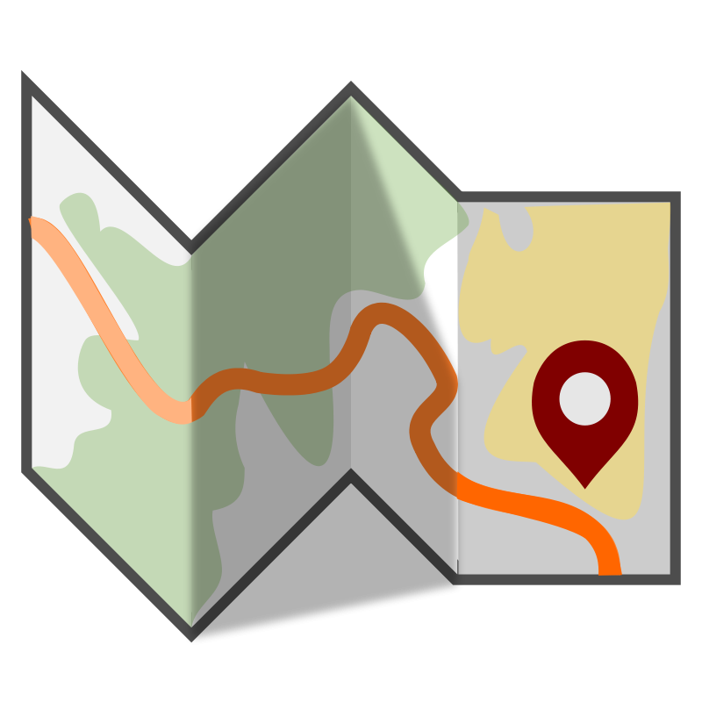
Please note: This may be a different route from prior years – we mix it up!

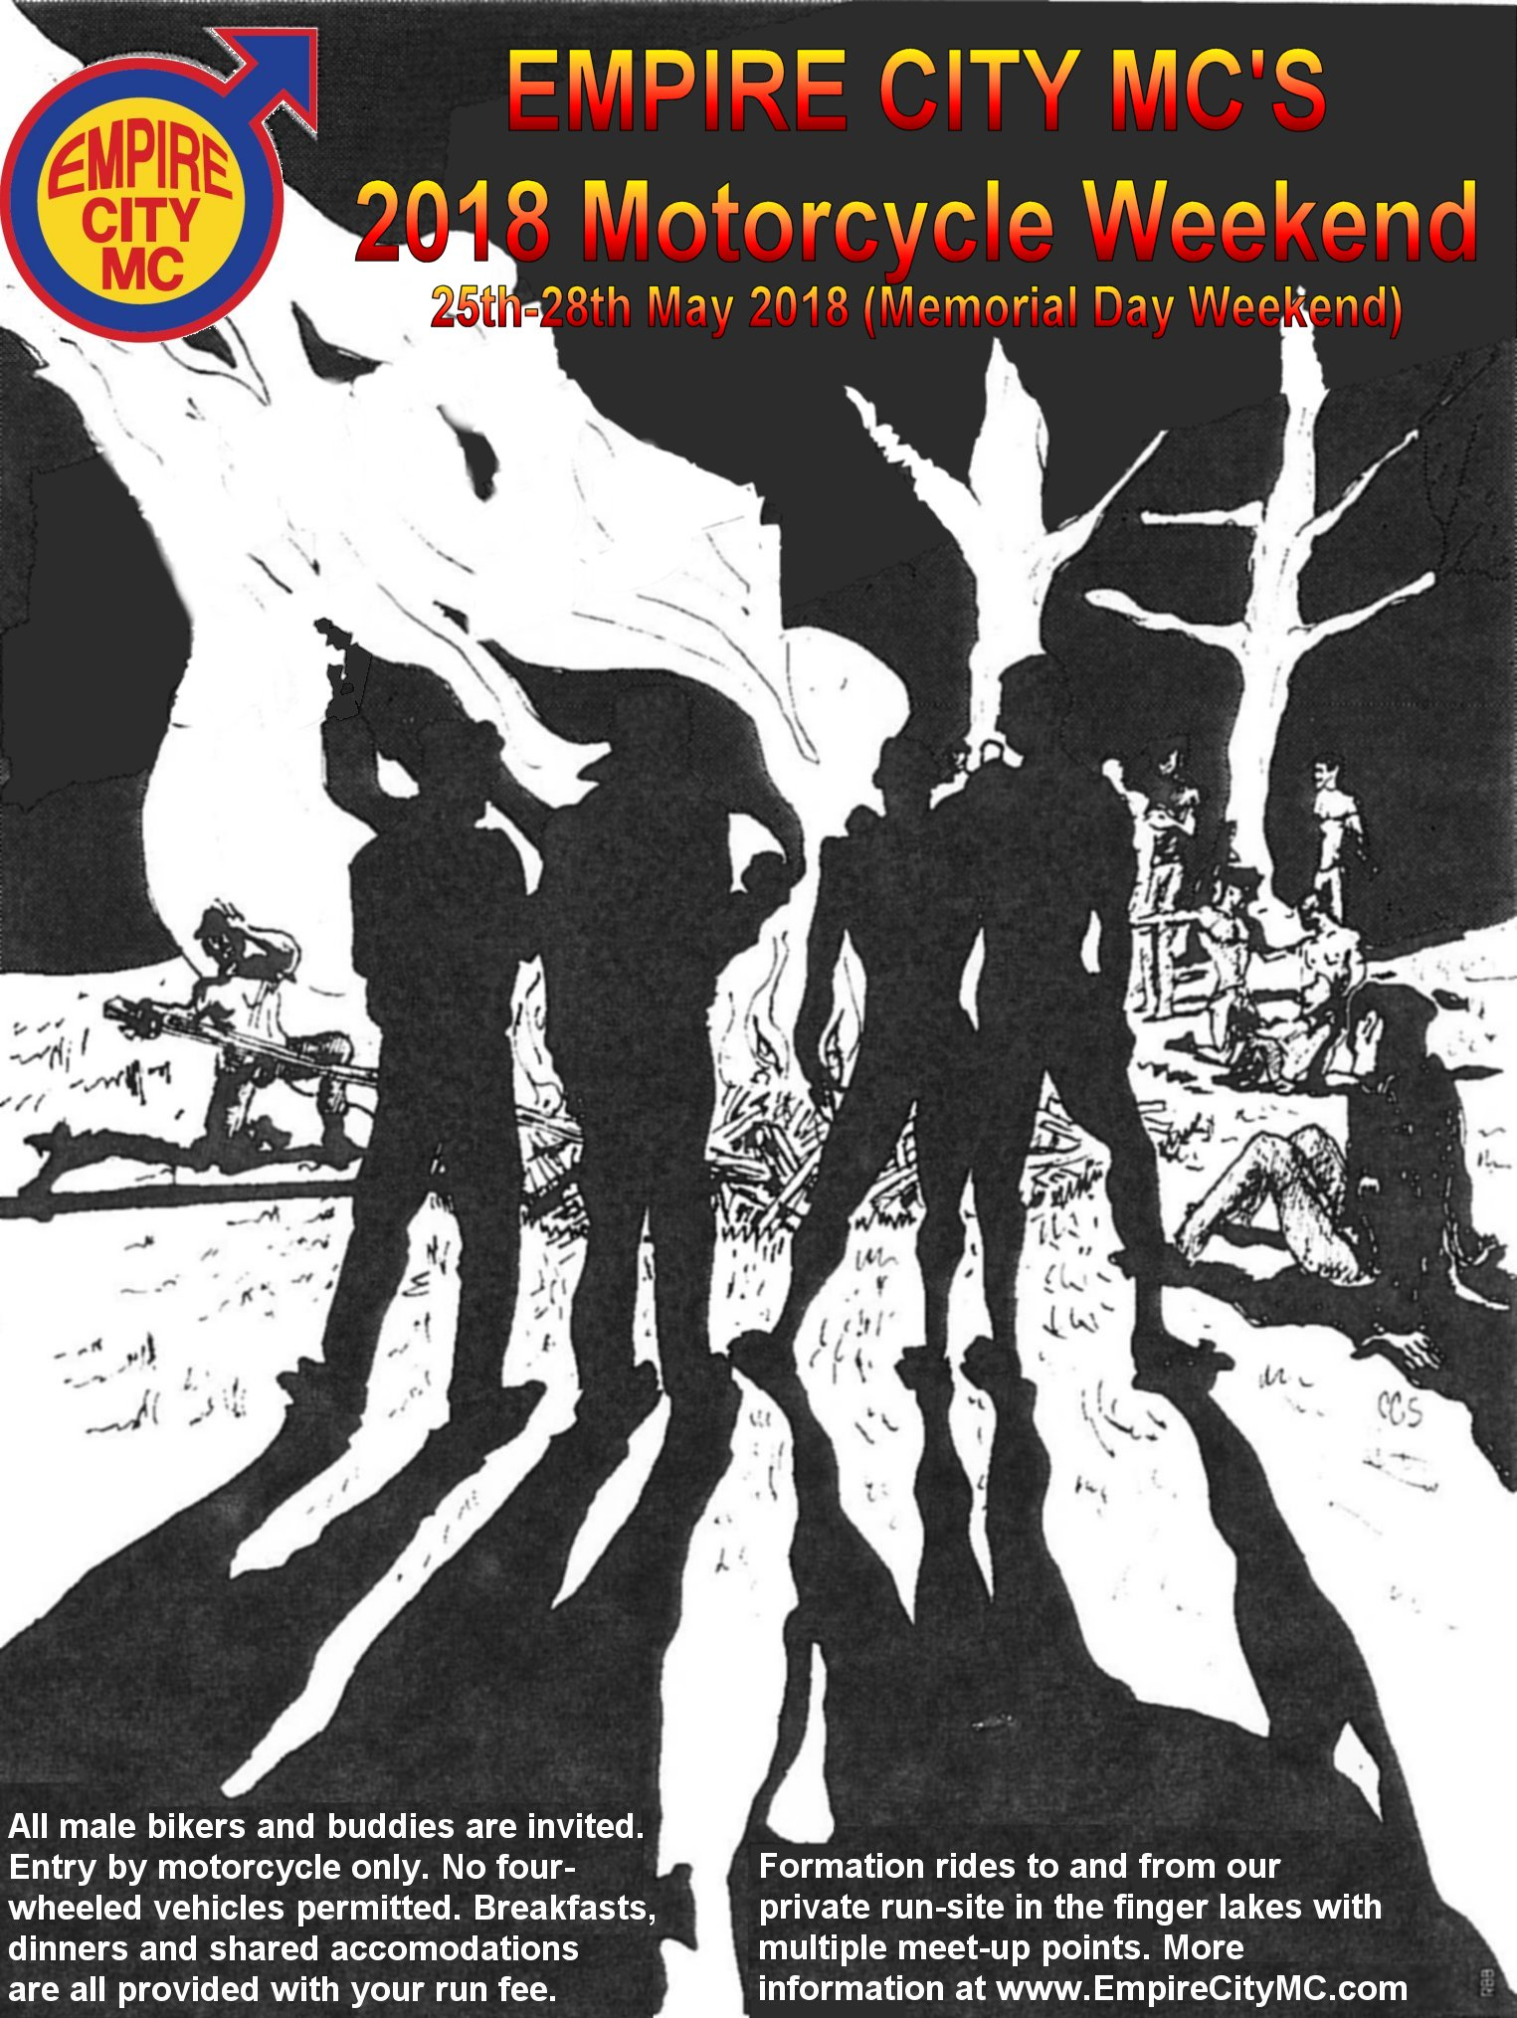
Don’t forget to tick the box on page one to let us know where you’re meeting up with us! Furthermore, it’s vital that your motorcycle is in good working order and you are on time to your respective meet-up location.

Meet-up Point “A” (Lexington Candy Shop, New York, NY)
09:00 - 10:00 ... Breakfast at Lexington Candy Shop, 1226 Lexington Ave at 83rd St, New York, NY 10028
10:00 - 11:00 ... Kickstands up from Lexington Candy Shop and ride 21 mi (0:60)

Meet-up Point “B” (Left Exit Gas Station on the Palisades Pkwy, MM 1.7)
11:00 - 11:15 ... Gas up, bathroom/snack break. Note: GPS: 41°01'39.0"N 73°56'17.9"W
11:15 - 12:15 ... Kickstands up and ride 54 mi (0:60)

Meet-up Point “C” (Quickway Twin Cone/Quickway Diner/Citgo, RR 17K, Bloomingburg, NY 12721)
12:15 - 12:30 ... Gas up, bathroom/snack break/ice cream
12:30 - 13:45 ... Kickstands up and ride ~82 mi (0:75)

Meet-up Point “D” (LUNCH STOP at Butterfields Cafe, 16 Division St, Deposit, NY 13754)
13:45 - 14:45 ... Gas up at the Citgo, then ride around the corner to Butterfield’s Café for lunch.
14:45 - 16:00 ... Kickstands up and ride 71 mi (0:66)

Meet-up Point “E” (Dandy Mini Mart, 363 White Wagon Rd, Sayre, PA 18840)
16:00 - 16:15 ... Gas up, bathroom/snack break
16:15 - 17:20 ... Kickstands up and ride 77 mi (0:70)

Meet-up Point “F” (7-Eleven/Mobil, 26 E Naples St, Wayland, NY 14572)
17:20 - 17:40 ... Gas up, bathroom/snack break
17:40 - 18:00 ... Kickstands up and ride 16 mi (0:20)

Meet-up Point “G” (The Ranch, 4872 Blank Rd, Hemlock, NY 14466)
18:00 ............... Arrive at The Ranch

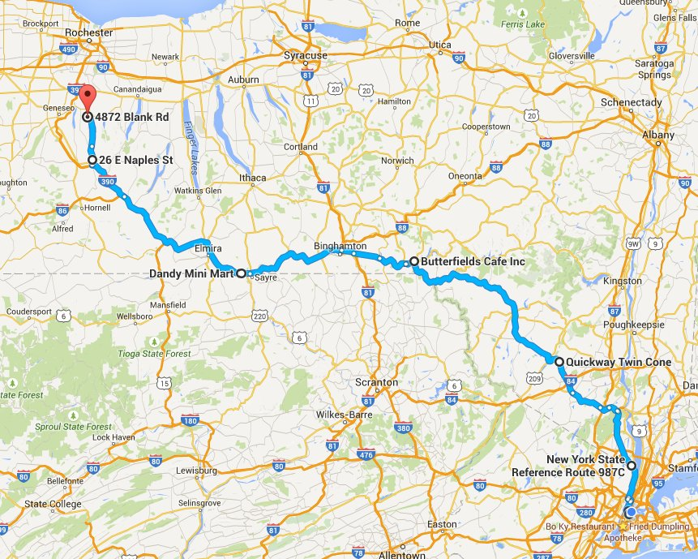
What do you need to bring?

A bed, clean linens and towels will be provided by The Ranch, but for your safety and comfort, we recommend you bring the following:

■ bike tool kit
■ extra bungee cords
■ rain gear
■ driving license
■ motorcycle registration
■ motorcycle insurance card
■ mobile phone charger
■ medications
■ motorcycle insurance card
■ dry clothing
■ club colours (vest)
■ favourite sex toy (optional) ;-)

NOTES:

You may interactively view/tweak our route map online at:
http://bit.ly/2018-BIKER

The Ranch has play space (should you be interested), as well as a pool, hot tub, bar, nature trails and more! Read more about The Ranch at http://j.mp/TheRanch

We will provide gourmet breakfasts on Saturday, Sunday and Monday and gourmet dinners on Friday, Saturday and Sunday dinners at The Ranch. All lunch-time meals and on-the-road meals are your own responsibility.

Save time and a stamp: pay online at https://ecmc-mw-2018.eventbrite.com

